Sample Promotional Messages and Materials for the National Institutes of Health Beauty + Health: Youth Graphic Medicine Challenge
Jump to: X | LinkedIn and Facebook | Instagram | Email and Newsletters | Images

X
For adults, community organizations, and teachers:
- 📢 Announcing the NIH #GraphMedChallenge! Young people ages 13–25 can submit original comics how to reduce health risks from certain beauty products & behaviors used to meet societal beauty standards – and win up to $3,500! Closes 4/2/26. nih.gov/challenges/beauty-health-youth-graphic-medicine-challenge
- 💡 Do you know teens or young adults interested in creating comics? Do they have ideas about how to reduce health risks of certain beauty products and behaviors? Tell them to enter the NIH #GraphMedChallenge – they could win up to $3,500! Due 4/2/26. nih.gov/challenges/beauty-health-youth-graphic-medicine-challenge
- The NIH #GraphMedChallenge wants teens and young adults to share their ideas – using comics and storytelling – about ways to reduce possible health risks of trying to meet society’s expectations for how people should look. Prizes up to $3,500! Due 4/2/26. nih.gov/challenges/beauty-health-youth-graphic-medicine-challenge

For teens and young adults:
- 📢 Teens & young adults: Use comics to show NIH the power of prevention! Submit an original comic by 4/2/26 about how to reduce health risks of beauty products & behaviors used to meet societal beauty standards. Win up to $3,500! #GraphMedChallenge nih.gov/challenges/beauty-health-youth-graphic-medicine-challenge
- 🗨️ Are you a teen or young adult interested in creating comics about beauty + health? Enter the NIH #ODPGraphMedChallenge — your work may be featured on NIH websites or social media, and you could even win up to $3,500! Submit by 4/2/26. nih.gov/challenges/beauty-health-youth-graphic-medicine-challenge
- Doing or using certain things to meet expectations about how we "should" look can sometimes come with health risks. The NIH #GraphMedChallenge invites teens & young adults to submit original comics about how to reduce those risks. Win up to $3,500! nih.gov/challenges/beauty-health-youth-graphic-medicine-challenge

LinkedIn and Facebook
For adults, community organizations, and teachers:
- A new National Institutes of Health (NIH) Office of Disease Prevention (ODP) Beauty + Health: Youth Graphic Medicine Challenge wants teens and young adults to share their ideas or experiences–through graphic medicine–about ways to reduce health risks from certain beauty products and behaviors that people use to meet societal beauty standards.
NIH wants to hear directly from young people who are ages 13–25 because of how early they become aware of beauty standards and begin to use beauty products and behaviors to adhere to those standards. Graphic medicine is a unique blend of art, personal narratives, and health information that can help make health-related content more accessible and understandable to younger audiences.
Winning entries will be awarded $500–$3,500 and comics may be featured on NIH websites and social media. Teens and young adults can submit their original comics until April 2, 2026. Learn more at nih.gov/challenges/beauty-health-youth-graphic-medicine-challenge.
#GraphMedChallenge #comics
- The National Institutes of Health (NIH) Office of Disease Prevention (ODP) is seeking submissions for original comics by teens and young adults ages 13–25 about ways to reduce health risks from certain beauty products and behaviors that people use to meet societal expectations about how people should look. Entries may be featured on NIH websites and social media, with cash prizes of up to $3,500! Comics accepted October 2, 2025, through April 2, 2026. Learn more at nih.gov/challenges/beauty-health-youth-graphic-medicine-challenge.
#GraphMedChallenge #comics
For teens and young adults:
- Teens and young adults ages 13–25: create comics that tell stories about beauty + health!
The National Institutes of Health (NIH) Office of Disease Prevention (ODP) wants you to share your ideas and experiences—through graphic medicine—about ways to reduce possible health risks that can come with trying to meet societal beauty standards, or society’s expectations of how people “should” look. Your original comics may be featured on NIH websites and social media, and winning entries will be awarded $500–$3,500! Up to five prizes will be awarded for each category: Teens (13–17 years old) and Young Adults (18–25 years old).

Submit your original comics by April 2, 2026. Learn more at nih.gov/challenges/beauty-health-youth-graphic-medicine-challenge.
#GraphMedChallenge #comics

Instagram
For adults, community organizations, and teachers:
- 📢 Do you know about the #ODPGraphMedChallenge for young people ages 13–25? The National Institutes of Health Office of Disease Prevention wants teens and young adults to submit original comics that show ways to reduce health risks from certain beauty products and behaviors that people use to meet societal beauty standards.
Winning entries could win up to $3,500! Challenge closes 4/2/2026.
Learn more: nih.gov/challenges/beauty-health-youth-graphic-medicine-challenge
#GraphicMedinine #Beauty #Health #HealthAndArt #NIH #TeachersOfInstagram #ScienceMatters #CommunityPartners #comics
For teens and young adults:
- 📢 Teens & young adults: can you share your experiences about beauty + health?
Submit your original comic about ways to reduce health risks from certain beauty products and behaviors that people use to meet societal beauty standards National Institutes of Health (NIH) Beauty + Health: Youth Graphic Medicine Challenge.
Your work may be featured on NIH websites and social media, and you could even win up to $3,500! Challenge open until 4/2/26.
Learn more: nih.gov/challenges/beauty-health-youth-graphic-medicine-challenge
#GraphicMedinine #Beauty #Health #HealthAndArt #NIH #TeachersOfInstagram #ScienceMatters #CommunityPartners #comics

Email and Newsletters
For adults, community organizations, and teachers:
- Subject: NEW Beauty + Health: Youth Graphic Medicine Challenge
The National Institutes of Health (NIH) Office of Disease Prevention (ODP) wants teens and young adults to share their ideas or experiences–through graphic medicine–about ways to reduce health risks from certain beauty products and behaviors that people use to meet societal beauty standards. Their original comics may be featured on NIH websites and social media, and winning entries will be awarded $500–$3,500! Up to five prizes will be awarded for each category: Teens (13–17 years old) and Young Adults (18–25 years old).
NIH wants to hear directly from young people because of how early age they become aware of beauty standards and begin to use beauty products and behaviors to adhere to those standards. Graphic medicine is a unique blend of art, personal narratives, and health information that can help make health-related content more accessible and understandable to younger audiences.
Submissions are open until than 11:59 p.m. Eastern Time (ET) on April 2, 2026. Learn more at nih.gov/challenges/beauty-health-youth-graphic-medicine-challenge
For teens and young adults:
- Subject: NEW Beauty + Health: Youth Graphic Medicine Challenge
It’s common for people to use or do certain things to meet expectations about how they think they should look. But sometimes, that can come with risks to their health.
That’s why the National Institutes of Health (NIH) Office of Disease Prevention (ODP) wants teens and young adults to share their ideas or experiences–through graphic medicine–about ways to reduce health risks from certain beauty products and behaviors that people use to meet societal beauty standards.
Your original comic may be featured on NIH websites and social media, and winning entries will be awarded $500–$3,500! Up to five prizes will be awarded for each category: Teens (13–17 years old) and Young Adults (18–25 years old).
Submissions are open until April 2, 2026. Learn more at nih.gov/challenges/beauty-health-youth-graphic-medicine-challenge.

Images (please use the high-resolution image files available in “resources” section of NIH.gov/challenges)
- Beauty + Health: Youth Graphic Medicine Challenge —rectangle
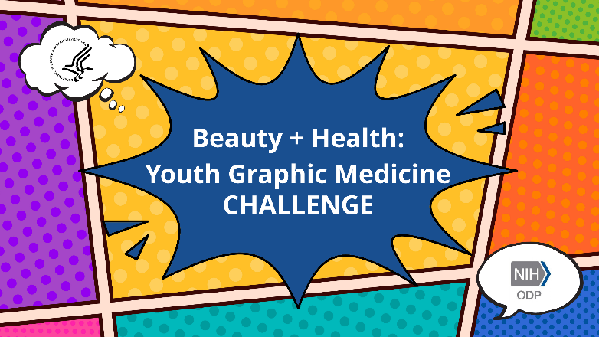
Suggested alt text: A series of colorful comic panels with a comment bubble and text in the middle that reads, “Beauty + Health: Youth Graphic Medicine CHALLENGE.” The Department of Health and Human Services logo is in a small thought bubble on the top left, and the National Institutes of Health Office of Disease Prevention logo is in a small comment bubble on the bottom right.
- Beauty + Health: Youth Graphic Medicine Challenge —square
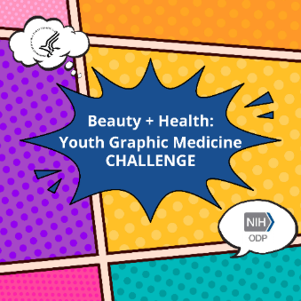
Suggested alt text: A series of colorful comic panels with a comment bubble and text in the middle that reads, “Beauty + Health: Youth Graphic Medicine CHALLENGE.” The Department of Health and Human Services logo is in a small thought bubble on the top left, and the National Institutes of Health Office of Disease Prevention logo is in a small comment bubble on the bottom right.

