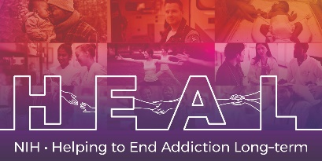

The Trial Making Test is Copyrighted.
To access this measure, please contact Dr. Jim Hom (info@neuropsych.com) to obtain a license for this measure

Please indicate that you are conducting research as part of the NIH HEAL Initiative:

“Our study is a NIH funded study. We are part of the HEAL Initiative.”

Once you have license permission, please share your email confirmation with HEAL_CDE@hsc.utah.edu for access to the NIH HEAL Initiative’s CDE for this measure.

English CRF is available.

