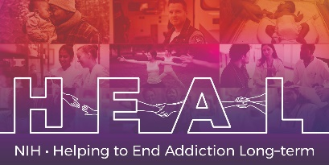

The Pediatric Pain Screening Tool Child and Adolescent Form – PPST is Copyrighted. To access this measure, please email the Copyright Author Laura Simons at lesimons@stanford.edu.
When applying for access, please indicate that you are conducting research as part of the NIH HEAL Initiative:

“Our study is a NIH funded study. We are part of the HEAL Initiative.”

Once you have license permission, please share your email confirmation with HEAL_CDE@hsc.utah.edu for access to the NIH HEAL Initiative’s CDE for this measure.

English CRF is available.

