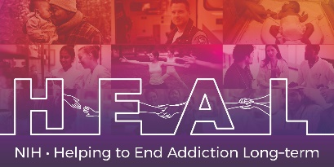

The Protocol for Responding to and Assessing Patients’ Assets, Risks, and Experiences (PRAPARE) is Copyrighted.

To obtain a license agreement, please contact the developers:
https://prapare.org/license-agreements/

Once you have license permission, please share your email confirmation with HEAL_CDE@hsc.utah.edu for access to the NIH HEAL Initiative’s CDE for this measure.

An English CRF is available.

