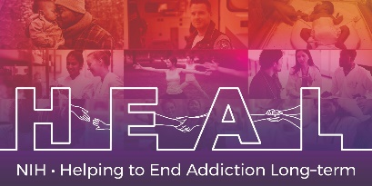

The PROMIS ® Pediatric Item Bank v2.0 – Anxiety – Short Form 8a- Spanish Translation is Copyrighted.

To access this measure, please contact HEAL_CDE@hsc.utah.edu to obtain this Core measure for your study.

The HEAL CDE team will obtain the Copyright license for your study and will send you the Spanish translation once the license agreement is procured.

The English CRF and CDEs are publicly available. You can locate these in the appropriate HEAL CDE Box folder.

