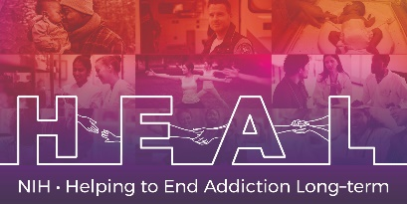

The PROMIS Early Childhood Parent Report Scale v1.0 - Global Health 8a - Spanish and Arabic Translations are Copyrighted.

To access this measure, please contact HEAL_CDE@hsc.utah.edu to obtain this Core measure for your study.

The HEAL CDE team will obtain the Copyright license for your study and will send you the Spanish/Arabic translation once the license agreement is procured.

The English CRF and CDEs are publicly available. You can locate these in the appropriate HEAL CDE Box folder.

