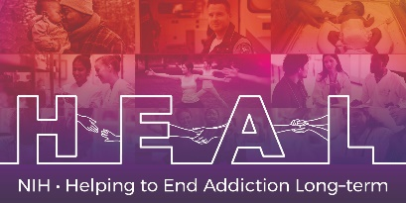

The PROMIS Early Childhood Pediatric Sleep Problems 4a is Copyrighted.

To access this measure, please contact help@healthmeasures.net to obtain this Core measure for your study.

Once received, please forward your Copyright license procurement to our HEAL CDE team at HEAL_CDE@hsc.utah.edu and our team will grant access to the NIH HEAL Initiative’s CDE for this measure

English and Spanish CRF’s are available.

