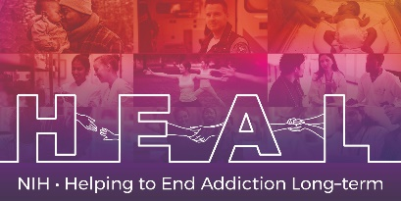

The UCLA PTSD Reaction Index is copyrighted and requires a license agreement.

The various versions of the UCLA PTSD Reaction Index for DSM-5 measures are proprietary and can only be licensed for use from Behavioral Health Innovations (www.reactionindex.com). There are 4 versions:

- The Brief Screen for Child/Adolescent Trauma and PTSD
- The Child/Adolescent version (self report)
- The Parent/Caregiver version
- The Parent/Caregiver version for Children Aged 6 and Younger.

To access this measure, please first obtain a license from Behavioral Health Innovations. Your study will be responsible to pay any licensing fees. Then contact HEAL_CDE@hsc.utah.edu to obtain CDE details for the version you have licensed. Currently available is the CDE detail file for the Child Adolescent Self-Report version. Once verification of your license has been received by the HEAL CDE team, access to the NIH HEAL Initiative’s CDE for this measure will be granted.

